INSTALLATION REQUIREMENTS FOR MEDICAL IMAGE ENCRYPTION USING AES AND DES (CRYPTOGRAPHY)

1. JDK (VERSION 8 OR BELOW NOT HIGER)
2. NETBEANS

INSTALLATION PROCEDURE

* OPEN NETBEANS
* CLICK FILE -> IMPORT PROJECT -> FROM ZIP -> BROWSE -> SELECT ZIP FILE(Cryptography.zip) -> import.
* CLEAN AND BUILD PROJECT THEN RUN.

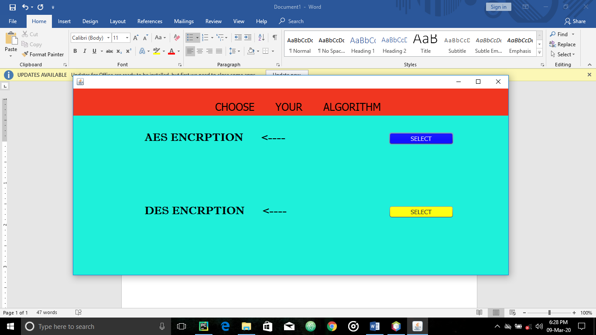

PROJECT LANDING PAGE

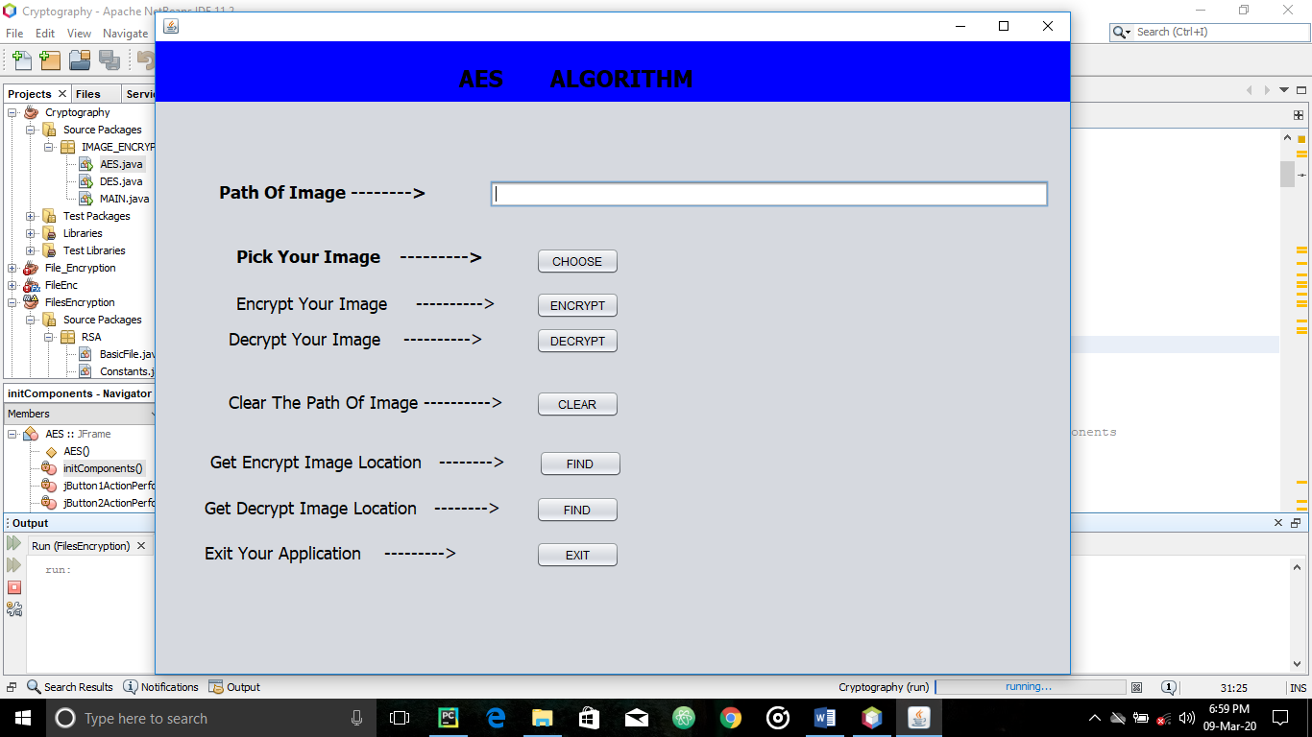

AES Algorithm page.

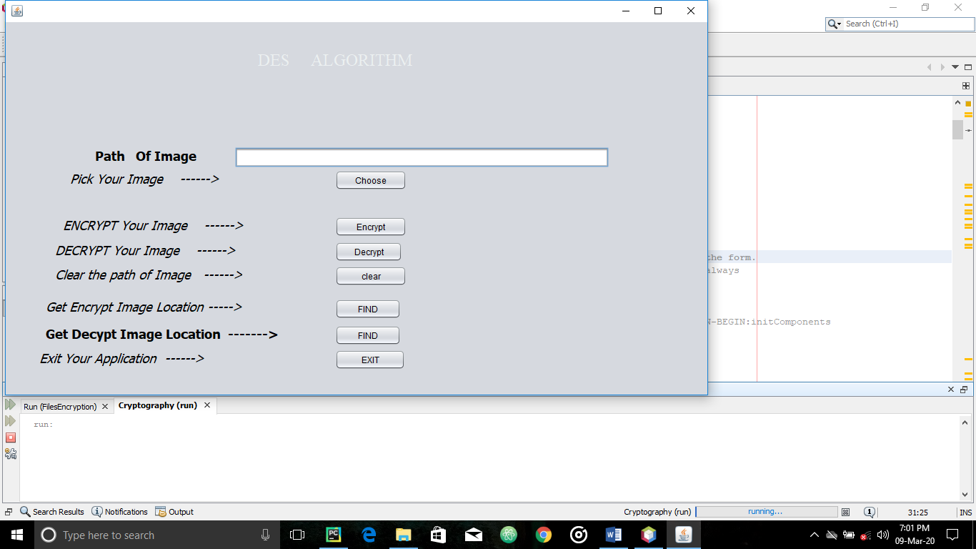

DES Algorithm page.

**PROCEDURE FOR ENCRYPTING IMAGES**

* Click on choose
* Use the browse menu to select the image you want to encrypt from your files.
* After selecting image, click encrypt. (You will get a prompt notifying you of success or failure.)

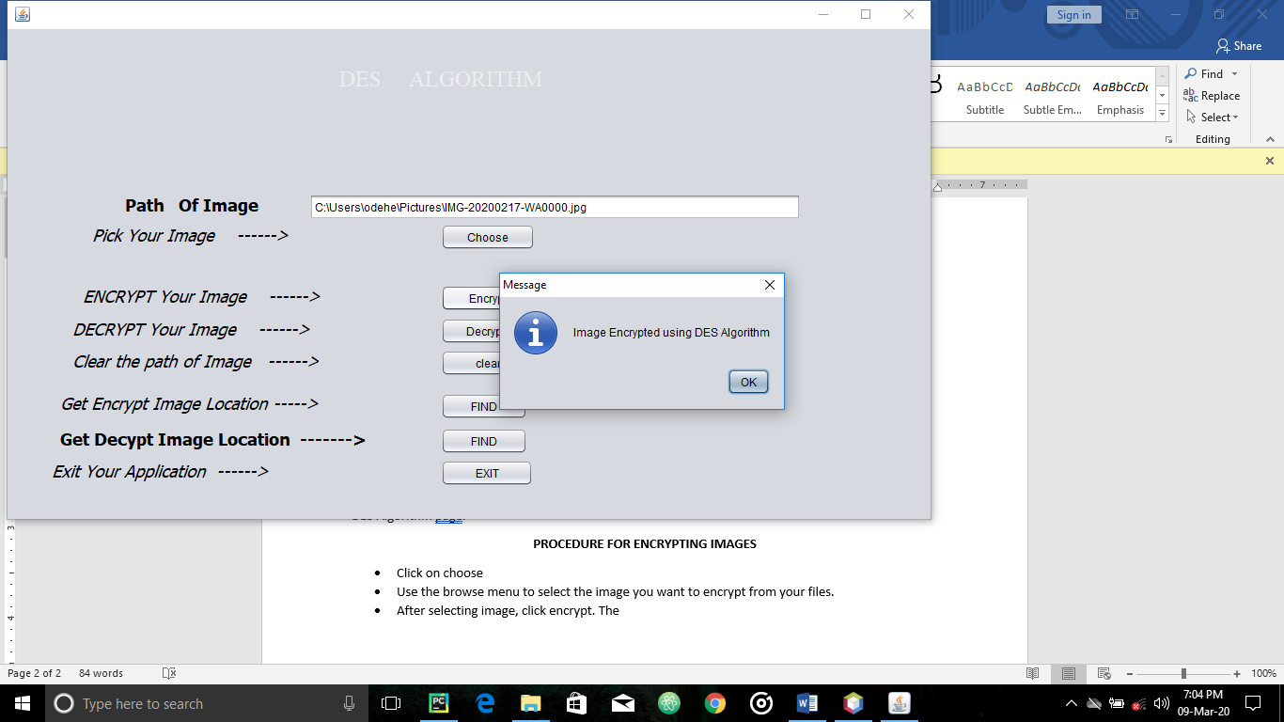

**Success Prompt.**

**For AES Algorithm, encrypted images are saved in the project folder (Cryptography/AES/encrypted/enc_imageName)**

**For DES Algorithm, encrypted images are saved in the project folder (Cryptography/DES/encrypted/enc_imageName)**

**PROCEDURE FOR DECRYPTING IMAGES**

* Click on choose
* Use the browse menu to select the encrypted image you want to decrypt from your files.
* After selecting image, click decrypt. (You will get a prompt notifying you of success or failure.)

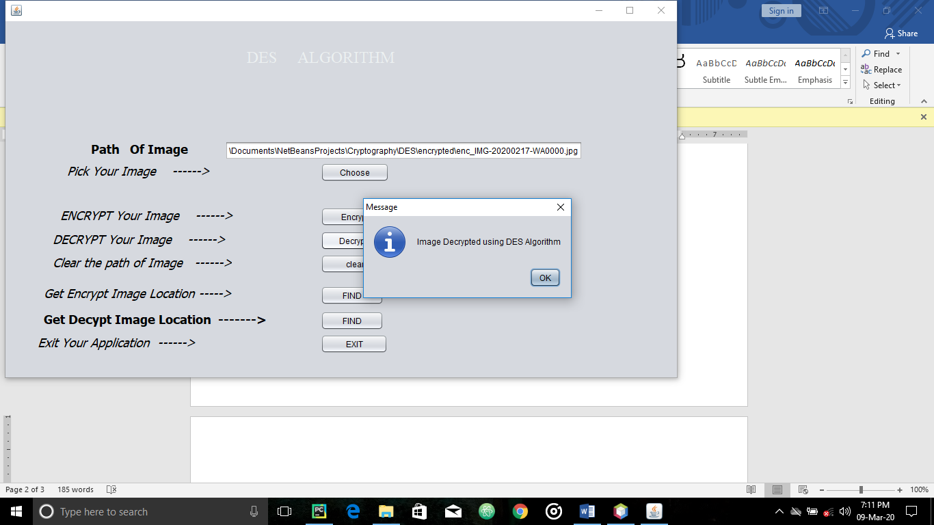

**Success Prompt.**

**For AES Algorithm, decrypted images are saved in the project folder (Cryptography/AES/decrypted/dec_imageName)**

**For DES Algorithm, decrypted images are saved in the project folder (Cryptography/DES/decrypted/dec_imageName)**

**NOTE: YOU CAN ONLY DECRYPT IMAGES USING AES THAT WERE ENCRYPTED USING AES, SAME RULE APPLIES FOR THE DES ALGORITHM.**

**NAGODE.**